Call by Reference
23-11-25
Aim – Write two programs to demonstrate call by value and call by reference respectively
Theory –
Call by value passes copies of variables to functions, so original data remains unchanged.
Call by reference passes addresses, allowing functions to modify actual variables directly in memory.
A1.
#include <stdio.h>

void cbv(int x) {
x = x + 10;
printf("Inside call by value: x = %d\n", x);
}

void main() {
int a = 5;

printf("Before call by value: a = %d\n", a);
cbv(a);
printf("After call by value: a = %d\n\n", a);
}
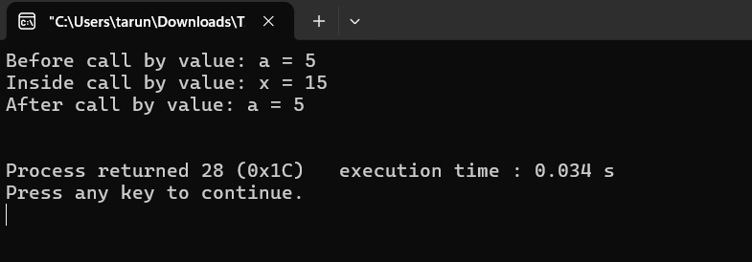
A2.
#include <stdio.h>
void cbr(int *y) {
*y = *y + 10;
printf("Inside call by reference: y = %d\n", *y);
}

void main() {
int a = 5;
printf("Before call by reference: a = %d\n", a);
cbr(&a);
printf("After call by reference: a = %d\n", a);
}
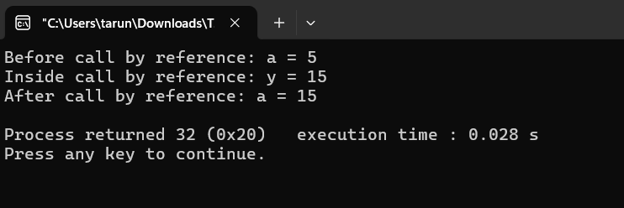
Conclusion
This program uses call by value and call by reference in order to not change and change the values in the original memory location inside the functions.

